DSC 530 Week 5 and 6 Supplemental Notes from Instructor

Hands on Data Analysis with Pandas (2nd Edition)

Note. Only chapters with supplemental information are provided in this document.

Table of Contents
Chapter 4 Supplemental Notes 1
File: 0-weather_data_collection.ipynb 2
File: 2-dataframe_operations.ipynb 3
File: 3-aggregations.ipynb 4
File: 4-time_series.ipynb 9
File: understanding_window_calculations.ipynb 9
General Steps to Address Deprecation 11

Chapter 4 Supplemental Notes

File: 0-weather_data_collection.ipynb
You have conducted a similar task in Chapter 3 when you conduct an API call to request temperature data from the National Centers for Environmental Information (NCEI). This chapter, you can request weather data from the same source and therefore you may use the same token or request a new token to conduct this task.

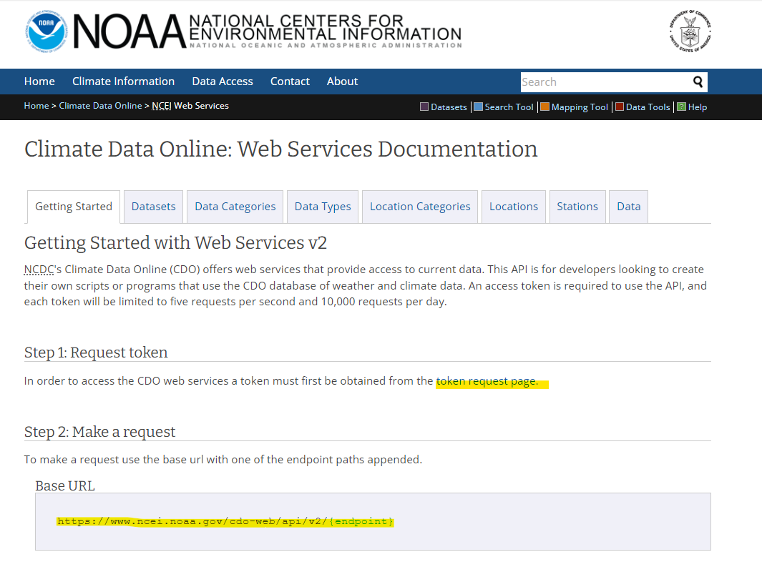
Once you update the token in the make_requests function, then you can proceed to the next step: Collect All Data Points for 2018 in NYC (Various Stations).

This code will take about 10-20 minutes to run, and the way to verify it is that the IPython.display will change the output on the ‘date’ that is collected. It will start on 2018-01-01 and ends with 2018-12-31.
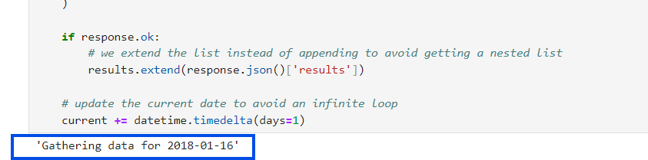

However, if you don’t have the capacity to download and wait for the API call to finish, there is an existing data file in the ch-04/data folder, named nyc_weather_2018.csv

You will need to modify the codes following this API call to complete the steps to the SQL step. See the following screenshot
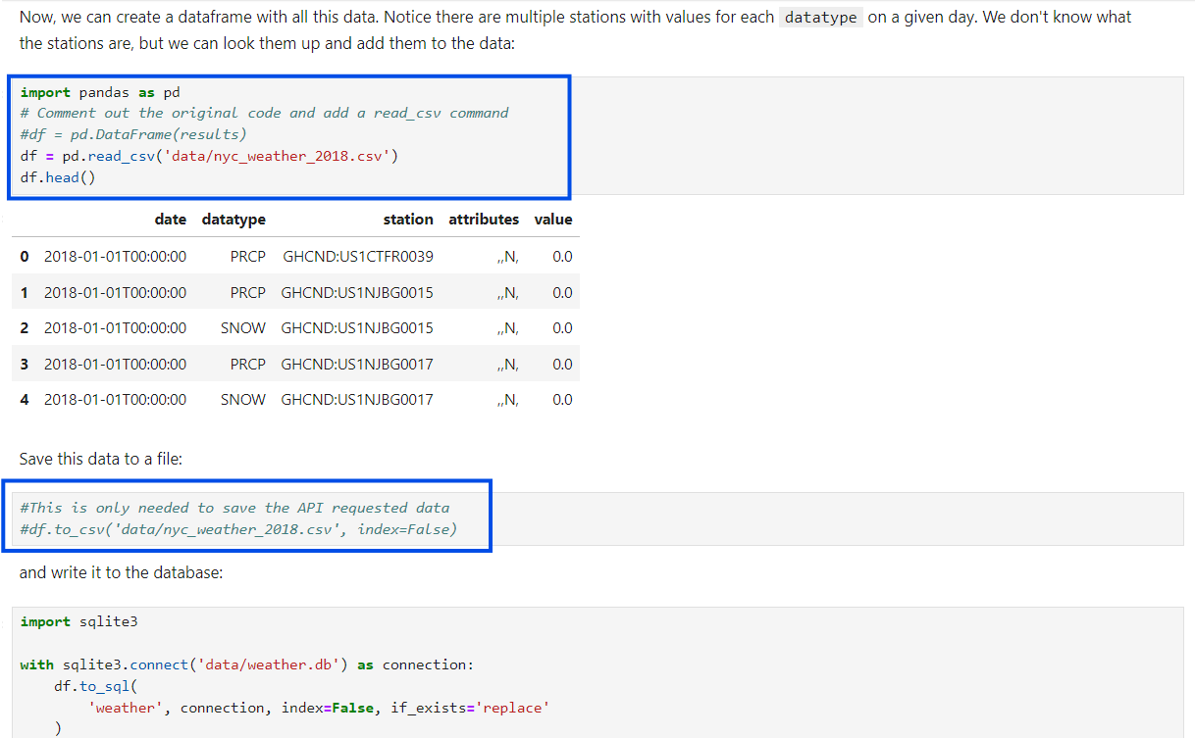

File: 2-dataframe_operations.ipynb
In the “Applying Functions” section, there are two demonstration codes to show applymap() and `iteritems()`. However, applymap() would give a warning due to the pandas version we use and an attribute error will show for the use of iteritems()

First, replace the code with the following fb.apply(lambda x: x.apply(lambda y: len(str(np.ceil(y)))) and it will avoid the warning for applymap()
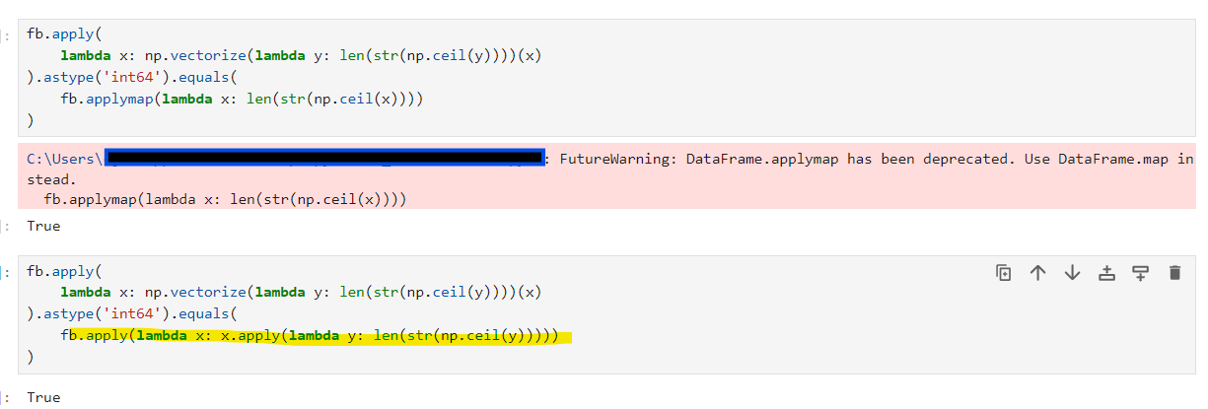
Then, the next code chunk would need a simple modification if you want to give it a try (See the highlighted codes). The point here is simply to illustrate how inefficient the use of iteritems() in the original code and now items() compared to the vectorized operations.
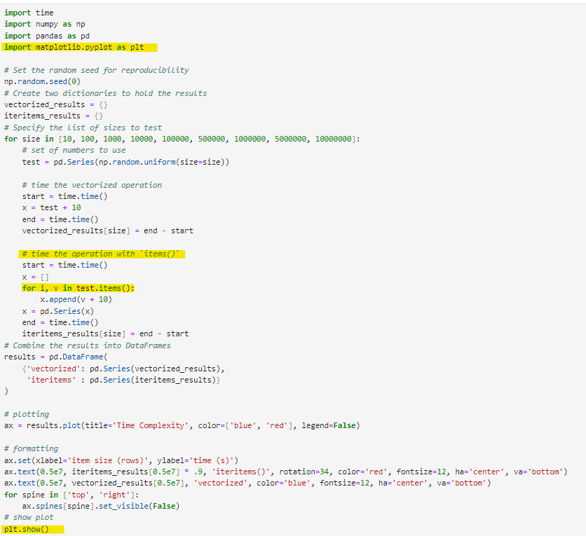
Add `import matplotlib.pyplot as plt’ and `plt.show() to the top and bottom of the script.
Replace ‘iteritems()` with ‘items()`

File: 3-aggregations.ipynb
In the Summarizing DataFrames section, there is a warning of using numpy functions and you have to replace it as a string by adding ‘ ‘.
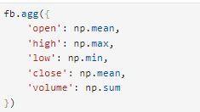 modify as 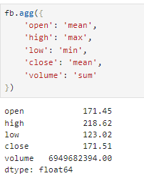

In the “Using groupby()” section, there are some future warnings of observed=False deprecated. Refer to the pandas.dataframe.groupby documentation to understand the change. To handle this because, the warning message gave you a choice of observed=False or observed=True to silence the warning.

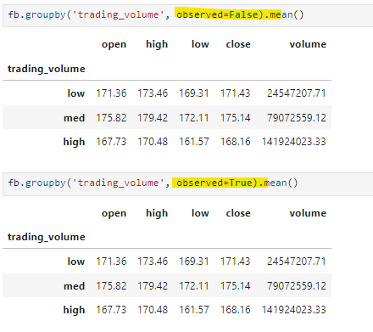
Because trading_volume is a categorical data type, the observed parameter specifies if it will group by only observed categories or all categories. You may need to continue to add this parameter to other group_by statements to avoid the warning messages.

In the same section where groupby() is used on the index, and this time the mean() calculation returns an error. There are 2 options to handle this:
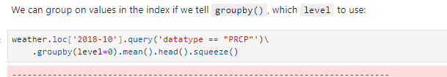
Option 1: add the parameter ` numeric_only=True` to mean()
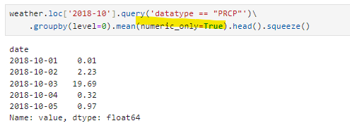
Option 2: use the agg(), aggregation method to calculate mean
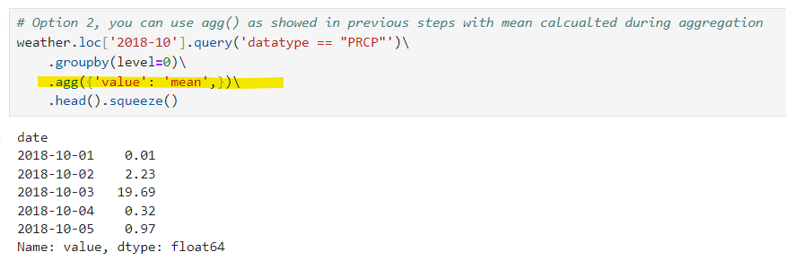

Error with `Grouper` object creation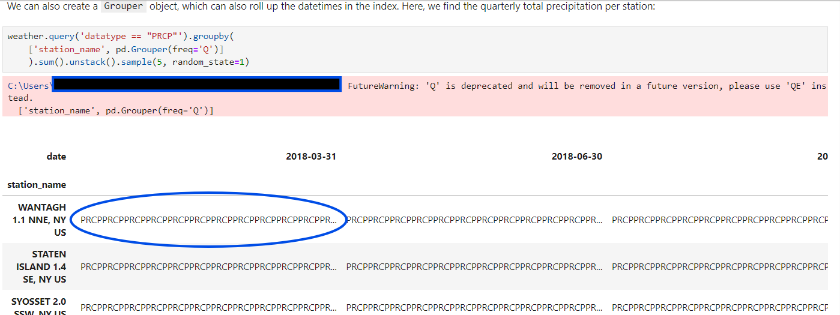
There are 2 issues with this code chunk, first, there is a warning of using ‘Q’ in the Grouper freq parameter, and it could be quickly addressed as the warning stated, change Q to QE.
The second issue you may encounter is highlighted in a circle, where the `sum()` is aggregating the PRCP values instead of the precipitation by each station.It is because the original dataframe has both “station_name” and “value” as columns, and so we have to specify what we are grouping. This is unlike the previous example of using groupby(level=0) in which the indexed dates were used as the category to group to.

Modify the codes by specifying the “value” column after the groupby() statement.
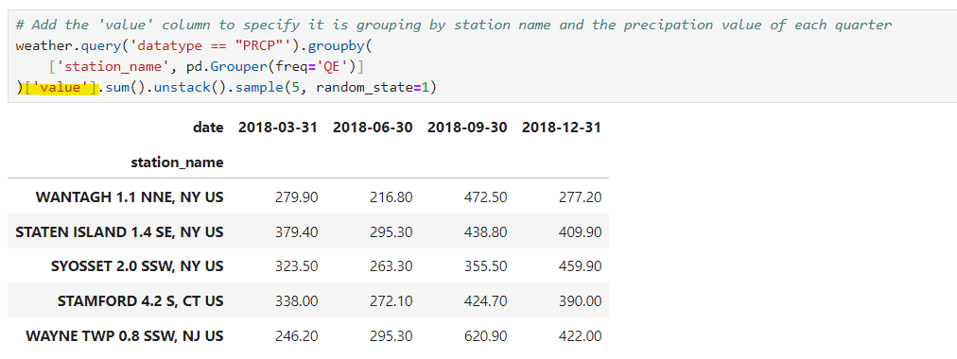
A similar error in the next code chunk of using filter()
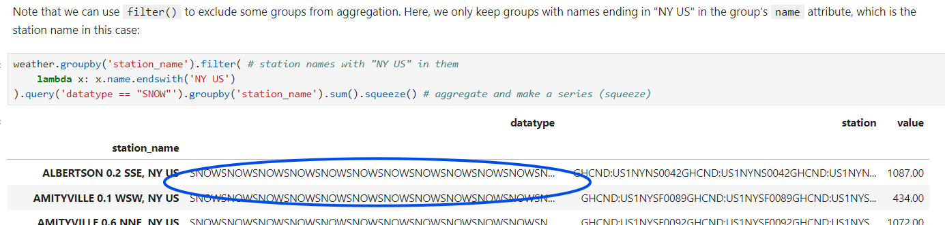
Add [‘value’] after the groupby() function to ensure we are grouping by station name and the value for stations only in NY US.
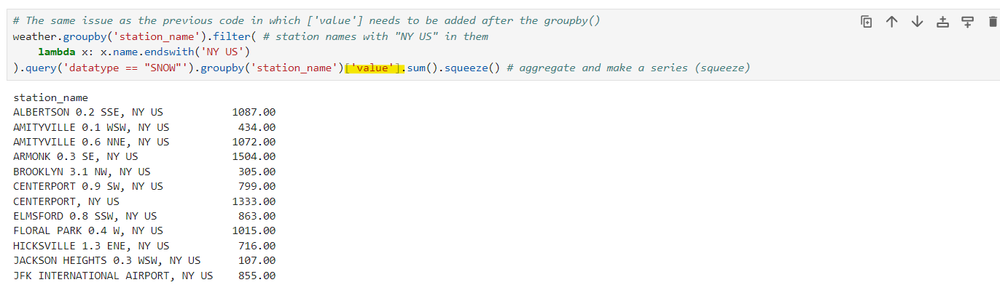

The next code chunk that demonstrates how to use nlargest() requires similar modification with the mean() and the freq() to stop the errors and warning.
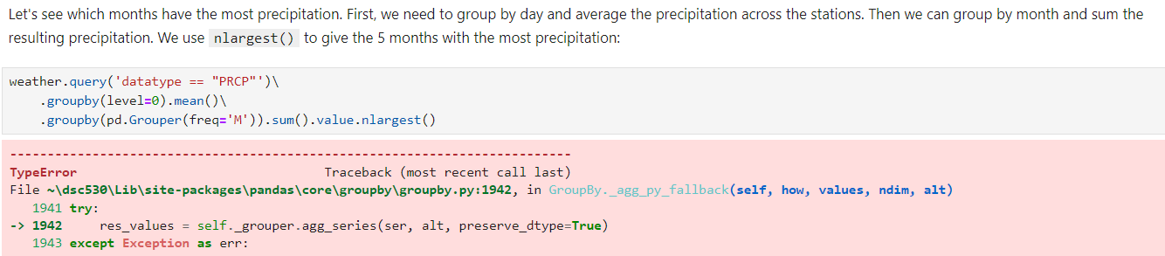
First, add numeric_only=True parameter to mean(). Then, modify “M” in freq() to “ME”.
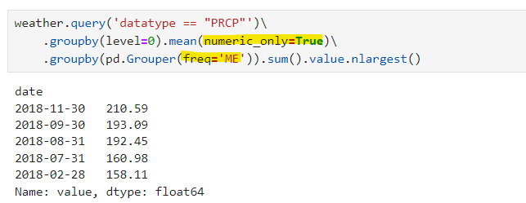
The next code chunk requires similar adjustment as shown above for several parts of the code. Here I’m highlighting what needs to be modified and skipped the errors and warnings message.
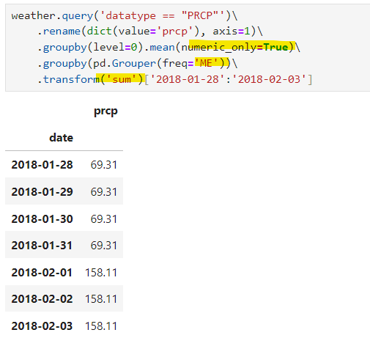
Similarly, for the Percentage of the Monthly Precipitation:
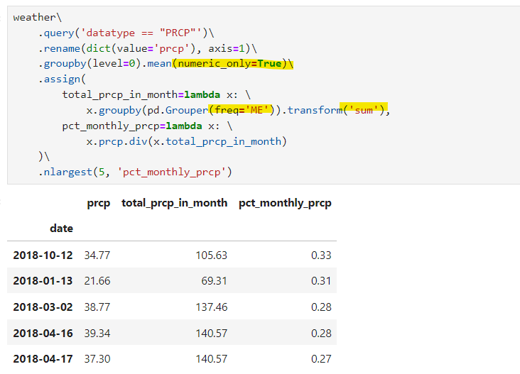

You will continue to do the same modification in the Pivot tables and crosstabs section in which you will encounter some similar warning regarding needing to specify observed=True in the pivot_table() function and recode np.mean to “mean” as a string.

File: 4-time_series.ipynb
Warning message for downsample to quarterly data, replace Q with QE as suggested.
FutureWarning: 'Q' is deprecated and will be removed in a future version, please use 'QE' instead.
fb.resample('Q').mean()

File: understanding_window_calculations.ipynb

There are several packages that could be missing or outdated for this script to work. If you encountered an error in which the visual display did not work, you will have to install some requirements with pip install in the command line interface and then return to the file to run it.
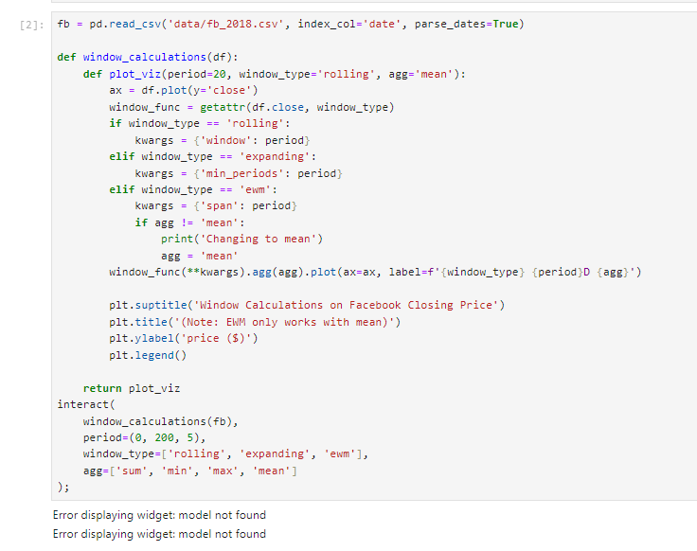
Once the packages are installed, then ensure the script is updated with the following import statements
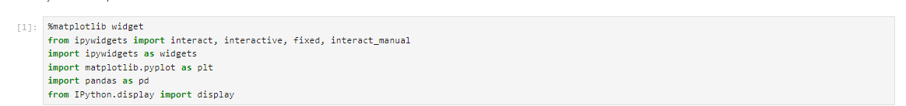

If the script runs successfully, you will see this interactive widget in your JupyterLab/ Jupyter Notebook.
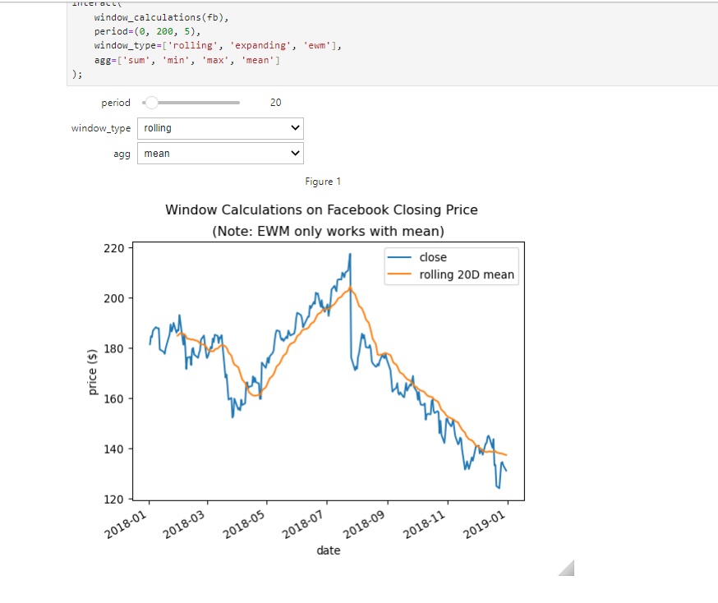

General Steps to Address Deprecation
- Check the framework’s documentation: Look for the official deprecation warning and suggested alternatives.
- Refactor code: Replace the deprecated methods with their recommended replacements or standard alternatives.
- Test the changes: Ensure the new code behaves as expected and that the deprecation warnings are resolved.

